How to get your own Notepad++ Theme

If you're someone who wants everything cool and is a programmer, but only Notepad ++, and some of the default, but boring, background colors, then this article might be helpful for you. This article I will take the XML script of Terminal Style 1.1 (made by me) for example. (Source code of background color is written in XML)

1 Enter the version:



As shown above, this tag is a version declaration. However, it's not normal declaration tag (as shown in the following table).

|  |  |
| --- | --- |
| Normal tags | Tag in source code |
| <?xml version=”1.0” encoding=”UTF-8”?> | <?xml version=”1.0” encoding=”Windows-1252”?> |

As shown in the table above, the tag in the source code also has an important word: encoding. A quick look at this syntax: This is the code declaration function. In this example, the encoding used is ANSI (aka Windows 1252) instead of UTF-8. However it does not affect to my Unicode (UTF-8) ok.

2 Enter the tags

Type the 2 code lines:



Unlike HTML, the tags in XML are made by your own rules. Therefore, you do not need to worry about it reporting an error, but for optimal code, turn off auto-close tags.

Then, type for me this code line:



But I must tell you: Square brackets ([]) are for example only, do not type (Type the name of the language in lower case letters). This is a LexerType tag, but like HTML, you can add attributes to an opening tag.

The first is func (name) (func () is the function to call in the article, the things in brackets <()> are the names of that func), [NAME] is the name of that language. For example: name = "c" shows this is the C programming language. In it, the variable [NAME] here is c.

Next, I will talk about func (desc). [DESCRIPTION] means the name of the language when displayed in Notepad ++. For example (I will take the example of 2 parts): name = "c" desc = "C" shows that this is C language, its display name is C.

NOTE: Before giving instructions, remember that you must have knowledge of color coding. Why? Because entering the color name directly into the fgColor and bgColor properties can cause a background error (the error rate is still calculated, I will give a test version to confirm). Therefore, first, you should use 6 hex numbers as instructed.

Code the script in the circle:

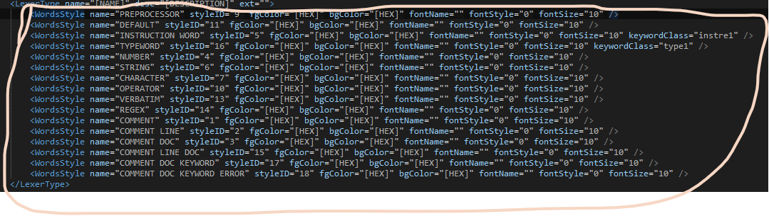

Please replace [HEX] with a 6-digit hex code (RRGGBB). Like whatever color you choose

Note:

1. Enter its correct Style ID. IDs are from left to right and right, respectively: 9-11-5-16-4-6-7-10-13-14-1-2-3-15-17-18.
2. bgColor of these lines must be uniform 1 color
3. The ID: 1-2-3-15-17-18 is the ID of the comment so have to unify 1 color of fgColor.
4. Designed so that it is easy to read. One taboo is that any color of the line matches bgColor.
5. Tags in XML have very strict rules. Therefore, the tag structure will be as follows:



By now, surely you know how to create your own background color?